

SmarTone-Vodafone
ADW Project

Architecture Design Documentation
Version 1.0
28 September 2005



SmarTone-Vodafone & NCR Confidential
Architecture Design Documentation
document preparation information
project name | prepared by (print) | signature | date prepared | DOCUMENT ID
SmarTone-Vodafone ADW Project
Customer information
Customer | Contact | Customer Account
SmarTone-Vodafone
GENERAL INFORMATION
project manager | security classification
Ken Chan | NCR and SmarTone-Vodafone Confidential
ORIGINATOR INFORMATION
ORIGINATOR |  | NCR ORGANIZATION NAME
 |  | Teradata Division
NCR Organization ADDRESS
22/F RBS Tower, Times Square, Causeway Bay, Hong Kong
PHONE NUMBER | FAX NUMBER |  | E-MAIL
VERSION INFORMATION
LAST UPDATED | MASTER VERSION LOCATION*
 | NCR / SmarTone-Vodafone Project Office
*For detailed information, see Guidelines below.

Note: The reader must verify that this is a current version before using.
CUSTOMER Acceptance
NAME (PRINT) | SIGNATURE |  | DATE
PHONE | FAX | E-MAIL
NAME (PRINT) | SIGNATURE |  | DATE
PHONE | FAX | E-MAIL
Guidelines
Master Version Location

Document Control
document distribution
name | title | organization
 |  | SmarTone-Vodafone
 |  | SmarTone-Vodafone
 |  | SmarTone-Vodafone
 |  | SmarTone-Vodafone
Ken Chan |  | NCR
Garrett Siu |  | NCR
Bun Wong |  | NCR
change history
date | change description | approved by

Table of Contents
1. INTRODUCTION 6
2. LOGICAL ArchitECTURE 7
2.1 ADW AND BI PROJECT’S FUNCTIONAL LAYERS 7
2.1.1 SOURCE SYSTEM LAYER 9
2.1.2 ETL SERVER LAYER 10
2.1.3 ACTIVE DATA WAREHOUSE LAYER 11
2.1.4 INFORMATION ARCHIVE LAYER 11
2.1.5 BI TOOL LAYER 12
2.1.5.1 Framework Manager 12
2.1.5.2 ReportNet 13
2.1.6 END USERS LAYER 13
2.1.7 OTHER SYSTEM LAYER 13
2.1.8 RELATED APPLICATION LAYER 13
3. PHYSCIAL ARCHITECTURE 14
3.1 INTRODUCTION 14
3.2 ETL SERVER 15
3.3 Teradata SERVER 16
3.4 WEB SERVER 16
3.5 Cognos ReportNet Servers 17
3.6 ARCHIVE SYSTEM 18
3.6.1 Hardware and Software Overview 18
3.6.2 Data Backup 18
3.7 NETWORK ARCHITECTURE 19
4. APPLICATIONS 28
4.1 INTRODUCTION 28
4.2 DATA TRANSFORMATION AND LOADING APPLICATIONS 29
4.2.1 ETL Automation, Pre-processing and DataStage 29
4.3 Data management components 30
4.4 BUSINESS INTELLIGENCE APPLICATIONS 31
4.4.1 Framework Manager (FM) 31
4.4.2 ReportNet / DashBoard Report 31
4.4.3 Import / Export List 32
4.5 HP OpenView 33
5. DIRECTORY STRUCTURE 33
5.1 APPLICATION DIRECTORY STRUCTURE 33
5.2 CODES AND SCRIPTS DIRECTORY STRUCTURE 35
6. USER ACCOUNTS AUTHENTICATIONS AND SECURITIES 36
6.1 BI SERVER USER ACCOUNTS SETTINGS 36
6.2 Cognos ROLE settings 36
6.3 TERADATA DATABASE USER ACCOUNTS SETTINGS 36
6.3.1 Development user accounts authentications and securities 36
6.3.2 Production user accounts authentications and securities 37
6.3.3 System Account, Batch account Authentications and Securities 37
7. Appendix: 38
7.1 DEVELOPMENT, TESTING and PRODUCTION ENVIRONMENT 38
7.2 Host File Settings 39
7.3 Teradata USER Account List 39
7.4 TERADATA ROLE LIST 39

INTRODUCTION
The SmarTone-Vodafone ADW system allows SmarTone-Vodafone to attain a dedicated active data warehouse and business intelligence infrastructure
.

In ADW and BI Architecture is used to represent the overall structure of data flow, processes, communication and presentations that exist from the source to the target through out the whole project. There are two major reasons for developing ADW and BI System architecture.

Reference: The ADW and BI architecture serves as the point of reference that the manager and developer of the Data Warehouse and BI team to:
- Find out where the extra resources is needed
- Identify the location of issue when issue occurs
- Figure out the reusable components

Communication: The ADW and BI architecture act as a communication tool, allow developers to have a simple and complete picture of what makes up the ADW and BI infrastructure. Also understand how each components work together.

In this document, we will look at the whole architecture of the ADW and BI system first, and then work down to the particulars.

LOGICAL ArchitECTURE

ADW AND BI PROJECT’S FUNCTIONAL LAYERS
There are eight functional layers in our ADW and BI architecture environment.
- Source Systems
- ETL Server
- Active Data Warehouse
- Information Archive
- BI Tool
- End Users
- Related applications
- Other Systems

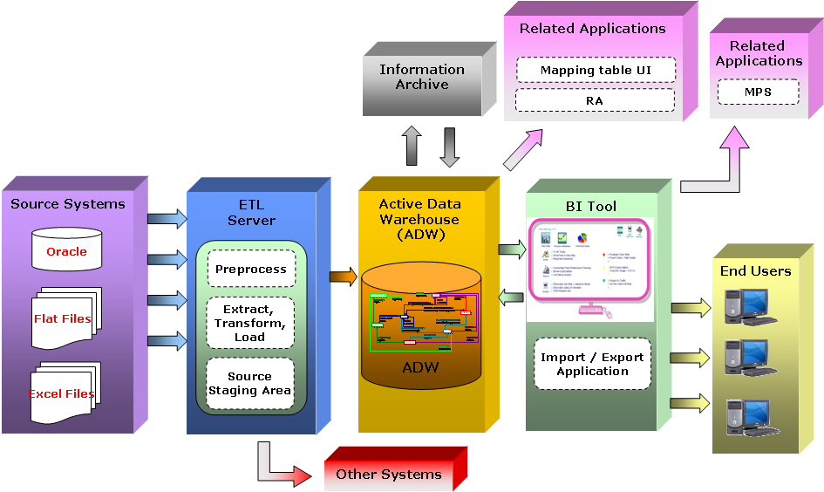

The Source Systems Layer holds the raw data for the data warehouse. These data will be extracted through operational source system.

ETL Server Layer transforms the data extracted from the operation source systems to the data warehouse.

Active Data Warehouse (ADW) Layer stores and manages the manipulated data with a well defined and structured model.

Information Archive Layer performs backup for the data in the Teradata System Layer.

BI Tool Layer performs business analysis on the data in the Teradata System Layer and shows the results to the End Users Layer.

End Users Layer acts as a media between users and the analytical results from the BI Tool Layer.

Related applications Layer refers to all applications providing/extracting data to/from the ADW, this includes the mapping table UI, RA and MPS.

Other Systems Layer refers to all systems that require the ETL Server Layer to provide source data.

SOURCE SYSTEM LAYER
Source System Layer consists of many operational systems that support the day to day activities for an organization. The operational source systems are formed by a wide variety of systems and applications. For example: Billing system, MD, Application Server…etc. However, operational systems always have their own definition on data, sometimes conflict with each other. Also, as data need to pass across different systems frequently, synchronization problem of the data will become a big issue.

In general, the operational data represent the primary data source for the ADW and BI infrastructure. Those data will be extracted and transformed into meaningful information for analytical purposes. Below are some examples where the source data may be extracted from:
- Billing System
- Application Server
- Oracle Finance
- FES (Frond End System)

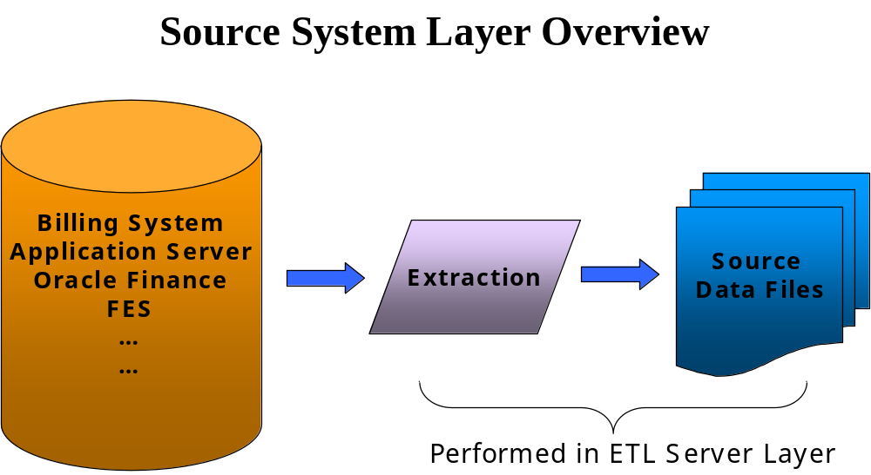

ETL SERVER LAYER
Data collected from Source System Layer usually have no consistency in naming conventions, definition, and contains dirty and redundant data. Therefore, an ETL Server Layer is required to perform the transformation and convert the source data into a well defined and structured model. Moreover, ETL Automation on the server serves as a scheduling tool to control the sequence of the ETL job flow.

As data are extracted from multiple sources, date manipulations are required to convert, cleanse and re-structure and the data into the Teradata System. The major component in this layer is listed as below:
- Pre-processing job
- Job Scheduling by ETL Automation
- Extraction, transformation, and loading

Below shows an example of the ETL process occurred in the ETL server layer. Data is extracted from the source system first and processed by the pre-processing job. Then the processed data will send to ETL Automation for scheduling. When it is ready to process, DataStage will perform the transformation and load the data into the Data warehouse. For more details about the ETL SERVER LAYER, please refer to the SMC-V ADW Project – ETL Technical Specification.doc document.

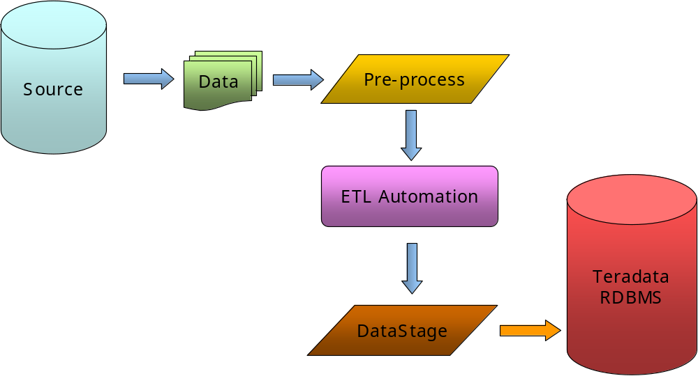

ACTIVE DATA WAREHOUSE LAYER
Active Data Warehouse layer provides a well structured and permanent place to store all the data extracted from the source system layer. The purpose of this is to provide a single view of enterprise’s data to all users. The primary member of this layer is the Active Data Warehouse System.

Active Data Warehouse System is a data management system which manages data in a subject oriented time variant and non volatile way that represents an enterprise view of the business. The ADW is setup from the beginning to accommodate the growth of historical information in an efficient way with the enterprise’s business rules. It is also set up to accommodate for any form of analytical technology.

INFORMATION ARCHIVE LAYER
Backups are so important in the maintenance of all servers. A well-designed backup strategic always protect the company against losing any important information in the event of hardware failures, software or operation error. For more detail about the INFORMATION ARCHIVE LAYER, please refer to the SMC-V ADW Project – BAR Service.doc document.

BI TOOL LAYER
The BI Tool Layer represents the tools that the end user normally uses to perform the day to day business analysis. In this layer, you should find the following three major components:
- Framework Manager
- Cognos ReportNet

Framework Manager
Framework Manager provides a common infrastructure across all Cognos business intelligence products. After a model has been created in the Framework Manager, it can be used to create ReportNet’s report.

ReportNet
ReportNet enables users to view the whole enterprise reports from the web portal. The architecture allows users to do ad-hoc queries to explore data from the ADW through business user view. ReportNet also provide advanced authoring features such as: integrated text, charts, graphs … etc.

END USERS LAYER
Analysis result needs to be presented to different users properly. Usually the result is shared between different business users across a range of departments. However some information is restricted to certain users or departments. In SmarTone – Vodafone ADW project, a Web Server is established as the key channel for presenting and sharing information between users and the analysis result.

OTHER SYSTEM LAYER
Some systems may require information from the ADW Server. In this case, the ETL Server Layer will be the media that generate the source data for these systems.

RELATED APPLICATION LAYER
The following migration and integration will be carried out to allow the existing application continuous to run on the new ADW system.
- Mapping table UI migration – migration of ‘user interface’ which allows the maintenance of reference code tables from existing DW into the new ADW.
- RA migration – migration of RA ‘reconciliation’ reports from existing DW into the new ADW.
- MPS integration – Integration of in-house MPS application with Cognos ReportNet.

PHYSCIAL ARCHITECTURE

INTRODUCTION
Five systems will host the six function layers of the ADW and BI infrastructure listed below:
- Teradata Server
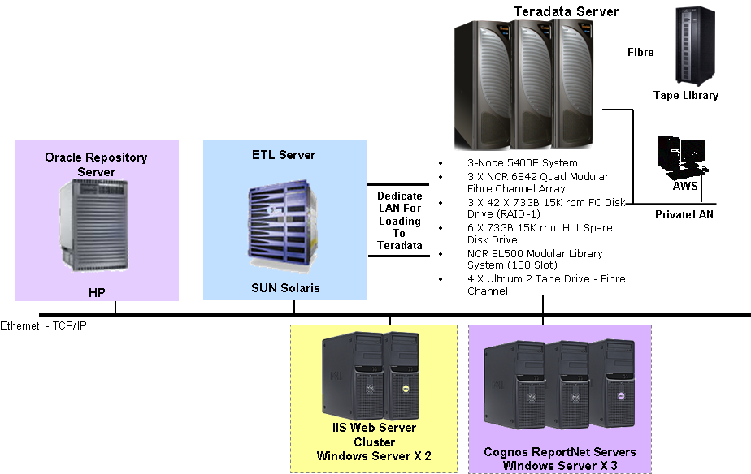
- DataStage ETL Server
- Cognos ReportNet Servers
- IIS Web Server
- Oracle Repository Server

ETL Server
ETL Server provides functionalities to carry out data manipulation operations. For example: pre-processing, transformation, data loading and job monitoring … etc.

Teradata Server
Teradata Server is the central store for all data; it provides information for the BI Servers and helps to perform complex transformation.

Cognos ReportNet Servers
BI Servers offer the reporting and analysis functionalities, such as reporting and OLAP.

IIS Web Servers
All business users will connect to BI Server via web browser. Web Servers serve as an interface between business users and the BI tool.

Oracle Repository Server
Repository Server acts as a repository for Cognos ReportNet and Erwin’s data.

ETL SERVER
ETL Server provides the following functions:
- Importing data from source system
- Performing pre-process and basic transformations
- Loading the data into Teradata Server
- Scheduling and monitoring the whole ETL process on different server

Below is the general configuration for the DataStage ETL Server is:
(…to be filled in, provided by SMC-V)

Teradata SERVER
Teradata RDBMS will occupy the database management system role in the SmarTone-Vodafone ADW project. As an active data warehouse management system, Teradata RDBMS provides a single view of truth of all company’s data and achieve a high performance by the power of parallelism database technology.

The current ADW Server hardware configuration is a 3-node 5400E System, with 3 X NCR 6842 Quad Modular Fibre Channel Array and a Microsoft Windows based workstation acting as a centralized administration workstation (AWS).

The general configuration for the 3-Node 5400E System is:
- 3 X NCR 6842 Quad Modular Fibre Channel Array
- 3 X 42 X 73GB 15K rpm FC Disk Drive (RAID-1)
- 6 X 73GB 15K rpm HotSpare Disk Drive
- NCR SL500 Modular Library System (100 Slot)
- 4 X Ultrium 2 Tape Drive – Fibre Channel

The configuration for each of the 5400E node is:
- Dual Intel Xeon 3.6GHz CPUs with Hyper-Threading technology
- 4GB Memory
- 2 X 36GB Internal Disk Drive
- Operating System: NCR UNIX SVR4 MP-RAS

WEB SERVER
Web Server is used to handle the web service requests from business users through the BI tool. In SmarTone-Vodafone ADW project, we will have two web servers together to form a cluster in order to improve availability, increase scalability and improve manageability.

Below is the configuration for each web server:
- Dual Intel Xeon 3.4GHz CPUs with Hyper-Threading technology
- 8GB Memory
- 2 X 73GB Disk Drives (RAID-1)
- 1 X Dual Port Gigabit Network Card
- Operating System: Windows 2003 Server – Enterprise Edition
- Software Components: Microsoft Internet Information Services “IIS”

Cognos ReportNet Servers
Cognos ReportNet Servers serve as the reporting and analytical purposes in the ADW and BI architecture. In general, Cognos ReportNet Servers are responsible for the following functions:
- Provides an gateway for users and their analytical data and reports
- Generate, store and manage all reports

An “f5” load balancer will be used in order to distribute end-user requests to the ReportNet Servers according to the pre-defined balancing rules.

Below is the configuration for each Cognos ReportNet server:
- Dual Intel Xeon 3.4GHz CPUs with Hyper-Threading technology
- 8GB Memory
- 2 X 73GB Disk Drives (RAID-1)
- 1 X Dual Port Gigabit Network Card
- Operating System: Windows 2003 Server – Enterprise Edition

ARCHIVE SYSTEM

Hardware and Software Overview
Tape library is an important component in the ADW infrastructure, providing backup and restores functionalities for the ADW server. In the SmarTone-Vodafone ADW project, StreamLine SL500 modular library will be used to perform the archive practices. The tape library has a direct connection to the ADW server and is administered through the NetVault tape library management software.

NetVault is used as the archive management software in this backup architecture. It provides a fast, reliable and easy to use archive and restore environment for ADW Server. The NetVault Server software will be installed on the AWS.

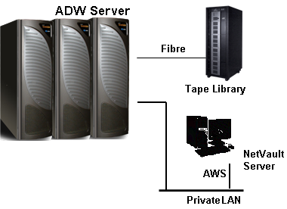

Data Backup
The plan for backup and restore data on the ADW Server is to archive the necessary backup data to tapes through NetVault into StreamLine SL500 modular library system. The details can be referenced to the SMC-V ADW Project – BAR Service.doc document.

NETWORK ARCHITECTURE
Below is the general network architecture design:

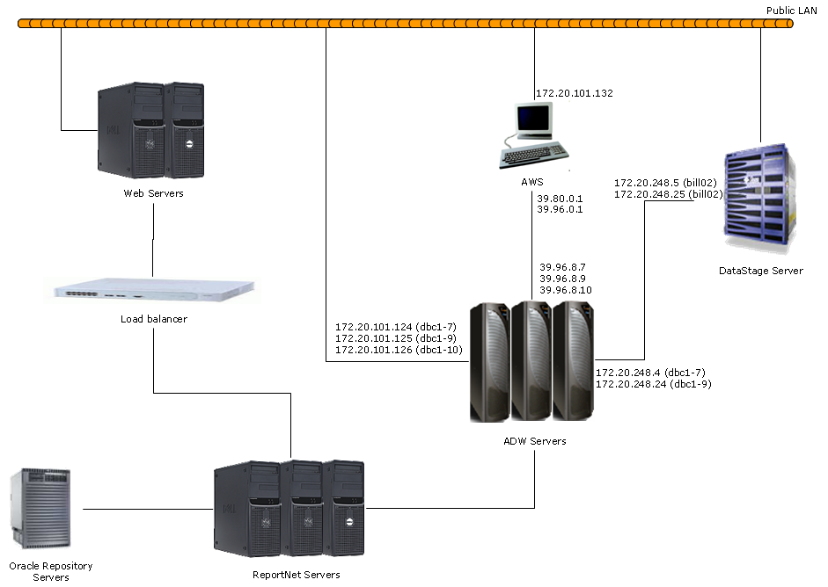

Network configuration for each machine is listed as below:

Machine (DNS Name) | Network Configuration
dbc1-7 | Local Area Connection to Public LAN
dbc1-7 | IP Address | 172.20.101.124
dbc1-7 | Subnet Mask | 255.255.255.0
dbc1-7 | Default Gateway | 172.20.101.255
dbc1-7 | Preferred DNS Server | 172.20.100.67
dbc1-7 | Alternate DNS Server | --
dbc1-9 | Local Area Connection to Public LAN
dbc1-9 | IP Address | 172.20.101.125
dbc1-9 | Subnet Mask | 255.255.255.0
dbc1-9 | Default Gateway | 172.20.101.255
dbc1-9 | Preferred DNS Server | 172.20.100.67
dbc1-9 | Alternate DNS Server | --
dbc1-10 | Local Area Connection to Public LAN
dbc1-10 | IP Address | 172.20.101.126
dbc1-10 | Subnet Mask | 255.255.255.0
dbc1-10 | Default Gateway | 172.20.101.255
dbc1-10 | Preferred DNS Server | 172.20.100.67
dbc1-10 | Alternate DNS Server | --
dbc1-7 | Local Area Connection to AWS
dbc1-7 | IP Address | 39.96.8.7
dbc1-7 | Subnet Mask | 255.240.0.0
dbc1-7 | Default Gateway | 39.111.255.255
dbc1-7 | Preferred DNS Server | --
dbc1-7 | Alternate DNS Server | --
dbc1-9 | Local Area Connection to AWS
dbc1-9 | IP Address | 39.96.8.9
dbc1-9 | Subnet Mask | 255.240.0.0
dbc1-9 | Default Gateway | 39.111.255.255
dbc1-9 | Preferred DNS Server | --
dbc1-9 | Alternate DNS Server | --
dbc1-10 | Local Area Connection to AWS
dbc1-10 | IP Address | 39.96.8.10
dbc1-10 | Subnet Mask | 255.240.0.0
dbc1-10 | Default Gateway | 39.111.255.255
dbc1-10 | Preferred DNS Server | --
dbc1-10 | Alternate DNS Server | --
dbc1-9 | Local Area Connection to DataStage Server (bill02)
dbc1-9 | IP Address | 172.20.248.24
dbc1-9 | Subnet Mask | 255.255.255.0
dbc1-9 | Default Gateway | 172.20.248.31
dbc1-9 | Preferred DNS Server | --
dbc1-9 | Alternate DNS Server | --
dbc1-7 | Local Area Connection to DataStage Server (bill02)
dbc1-7 | IP Address | 172.20.248.4
dbc1-7 | Subnet Mask | 255.255.255.0
dbc1-7 | Default Gateway | 172.20.248.15
dbc1-7 | Preferred DNS Server | --
dbc1-7 | Alternate DNS Server | --
aws01 | Local Area Connection to Public LAN
aws01 | IP Address | 172.20.101.132
aws01 | Subnet Mask | 255.255.255.0
aws01 | Default Gateway | 172.20.101.1
aws01 | Preferred DNS Server | 172.20.100.67
aws01 | Alternate DNS Server | 172.21.100.102
aws01 | Local Area Connection to ADW Server
aws01 | IP Address | 39.80.0.1
aws01 | Subnet Mask | 255.240.0.0
aws01 | Default Gateway | --
aws01 | Preferred DNS Server | --
aws01 | Alternate DNS Server | --
aws01 | Local Area Connection to ADW Server
aws01 | IP Address | 39.96.0.1
aws01 | Subnet Mask | 255.240.0.0
aws01 | Default Gateway | --
aws01 | Preferred DNS Server | --
aws01 | Alternate DNS Server | --
(WebServer1) | Local Area Connection to Public LAN
(WebServer1) | IP Address
(WebServer1) | Subnet Mask
(WebServer1) | Default Gateway
(WebServer1) | Preferred DNS Server
(WebServer1) | Alternate DNS Server
(WebServer2) | Local Area Connection to Public LAN
(WebServer2) | IP Address
(WebServer2) | Subnet Mask
(WebServer2) | Default Gateway
(WebServer2) | Preferred DNS Server
(WebServer2) | Alternate DNS Server
(WebServer1) | Local Area Connection to (LoadBalancer)
(WebServer1) | IP Address
(WebServer1) | Subnet Mask
(WebServer1) | Default Gateway
(WebServer1) | Preferred DNS Server
(WebServer1) | Alternate DNS Server
(WebServer2) | Local Area Connection to (LoadBalancer)
(WebServer2) | IP Address
(WebServer2) | Subnet Mask
(WebServer2) | Default Gateway
(WebServer2) | Preferred DNS Server
(WebServer2) | Alternate DNS Server
(LoadBalancer) | Local Area Connection to (WebServer1)
(LoadBalancer) | IP Address
(LoadBalancer) | Subnet Mask
(LoadBalancer) | Default Gateway
(LoadBalancer) | Preferred DNS Server
(LoadBalancer) | Alternate DNS Server
(LoadBalancer) | Local Area Connection to (WebServer2)
(LoadBalancer) | IP Address
(LoadBalancer) | Subnet Mask
(LoadBalancer) | Default Gateway
(LoadBalancer) | Preferred DNS Server
(LoadBalancer) | Alternate DNS Server
(LoadBalancer) | Local Area Connection to (ReportNet1)
(LoadBalancer) | IP Address
(LoadBalancer) | Subnet Mask
(LoadBalancer) | Default Gateway
(LoadBalancer) | Preferred DNS Server
(LoadBalancer) | Alternate DNS Server
(LoadBalancer) | Local Area Connection to (ReportNet2)
(LoadBalancer) | IP Address
(LoadBalancer) | Subnet Mask
(LoadBalancer) | Default Gateway
(LoadBalancer) | Preferred DNS Server
(LoadBalancer) | Alternate DNS Server
(LoadBalancer) | Local Area Connection to (ReportNet3)
(LoadBalancer) | IP Address
(LoadBalancer) | Subnet Mask
(LoadBalancer) | Default Gateway
(LoadBalancer) | Preferred DNS Server
(LoadBalancer) | Alternate DNS Server
(ReportNet1) | Local Area Connection to (LoadBalancer)
(ReportNet1) | IP Address
(ReportNet1) | Subnet Mask
(ReportNet1) | Default Gateway
(ReportNet1) | Preferred DNS Server
(ReportNet1) | Alternate DNS Server
(ReportNet2) | Local Area Connection to (LoadBalancer)
(ReportNet2) | IP Address
(ReportNet2) | Subnet Mask
(ReportNet2) | Default Gateway
(ReportNet2) | Preferred DNS Server
(ReportNet2) | Alternate DNS Server
(ReportNet3) | Local Area Connection to (LoadBalancer)
(ReportNet3) | IP Address
(ReportNet3) | Subnet Mask
(ReportNet3) | Default Gateway
(ReportNet3) | Preferred DNS Server
(ReportNet3) | Alternate DNS Server
(ReportNet1) | Local Area Connection to (Oracle)
(ReportNet1) | IP Address
(ReportNet1) | Subnet Mask
(ReportNet1) | Default Gateway
(ReportNet1) | Preferred DNS Server
(ReportNet1) | Alternate DNS Server
(ReportNet2) | Local Area Connection to (Oracle)
(ReportNet2) | IP Address
(ReportNet2) | Subnet Mask
(ReportNet2) | Default Gateway
(ReportNet2) | Preferred DNS Server
(ReportNet2) | Alternate DNS Server
(ReportNet3) | Local Area Connection to (Oracle)
(ReportNet3) | IP Address
(ReportNet3) | Subnet Mask
(ReportNet3) | Default Gateway
(ReportNet3) | Preferred DNS Server
(ReportNet3) | Alternate DNS Server
(Oracle) | Local Area Connection to (ReportNet)
(Oracle) | IP Address
(Oracle) | Subnet Mask
(Oracle) | Default Gateway
(Oracle) | Preferred DNS Server
(Oracle) | Alternate DNS Server
dbc1-7 | Local Area Connection to (ReportNet)
dbc1-7 | IP Address
dbc1-7 | Subnet Mask
dbc1-7 | Default Gateway
dbc1-7 | Preferred DNS Server
dbc1-7 | Alternate DNS Server
dbc1-9 | Local Area Connection to (ReportNet)
dbc1-9 | IP Address
dbc1-9 | Subnet Mask
dbc1-9 | Default Gateway
dbc1-9 | Preferred DNS Server
dbc1-9 | Alternate DNS Server
dbc1-10 | Local Area Connection to (ReportNet)
dbc1-10 | IP Address
dbc1-10 | Subnet Mask
dbc1-10 | Default Gateway
dbc1-10 | Preferred DNS Server
dbc1-10 | Alternate DNS Server
(ReportNet1) | Local Area Connection to ADW Server
(ReportNet1) | IP Address
(ReportNet1) | Subnet Mask
(ReportNet1) | Default Gateway
(ReportNet1) | Preferred DNS Server
(ReportNet1) | Alternate DNS Server
(ReportNet2) | Local Area Connection to ADW Server
(ReportNet2) | IP Address
(ReportNet2) | Subnet Mask
(ReportNet2) | Default Gateway
(ReportNet2) | Preferred DNS Server
(ReportNet2) | Alternate DNS Server
(ReportNet3) | Local Area Connection to ADW Server
(ReportNet3) | IP Address
(ReportNet3) | Subnet Mask
(ReportNet3) | Default Gateway
(ReportNet3) | Preferred DNS Server
(ReportNet3) | Alternate DNS Server
bill02 | Local Area Connection to ADW Server (dbc1-7)
bill02 | IP Address | 172.20.248.5
bill02 | Subnet Mask | 255.255.255.0
bill02 | Default Gateway | --
bill02 | Preferred DNS Server | --
bill02 | Alternate DNS Server | --
bill02 | Local Area Connection to ADW Server (dbc1-9)
bill02 | IP Address | 172.20.248.25
bill02 | Subnet Mask | 255.255.255.0
bill02 | Default Gateway | --
bill02 | Preferred DNS Server | --
bill02 | Alternate DNS Server | --

APPLICATIONS

INTRODUCTION
With the three server systems – ETL Server, ADW Server and BI Server, corresponding application need to be installed.

Follow by the arrival of the source data, ETL Server need to perform the transformation and loading process to transfer the data into ADW Server. If error occurs, alert message will be sent to the HP OpenView. Next, in order to improve the performance of the BI Server, some data will be pre-aggregated and summarized in the ADW Server first. Finally, BI Server will perform analysis on these data to generate reports and OLAP cubes. Also a front end interfaces will be provided for these analysis.

Below is an overall application flow diagram.

DATA TRANSFORMATION AND LOADING APPLICATIONS

ETL Automation, Pre-processing and DataStage
ETL Automation acts as the part of the centralized scheduling tools in the whole ETL process. It is responsible for detecting the arrival of source data, schedules and executes the corresponding job. In general, data transformation and loading jobs from the ETL server to ADW Server are to be handled by the DataStage (Complex transformation and data cleansing can also be performed by ADW Server or Pre-processing job, for flexibility or performance). For details about ETL Automation, Pre-processing and DataStage, please refer to SMC-V ADW project - ETL Technical Specification.

Below is an overall ETL Server Application layout:

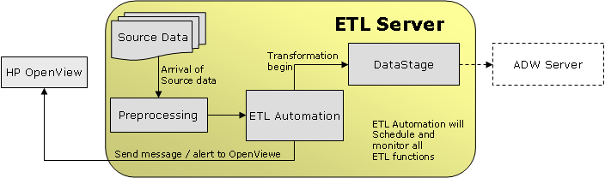
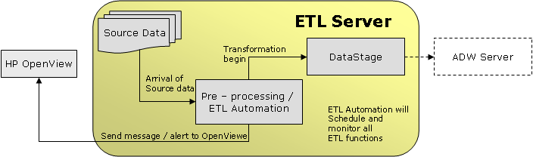

Data management components
Several databases have been created fro data transformation, data management and business analysis purposes. Below is the list of database created in ADW Server.

Database | Purpose
PRD_TEMP | Storing intermediate table
PRD_ETL | ETL Automation repository
PRD_ADW | Active Data Warehouse
PRD_BIZ_SUMM | Storing business summarize table
PRD_ADW_VW | Storing all views pulling data from PRD_ADW
PRD_BIZ_SUMM_VW | Storing all views pulling data from PRD_BIZ_SUMM
PRD_USER | Database created for users to store user level temporary data, for each user, they will have their own small database in this database.

Below is an overall ADW Server data structure:
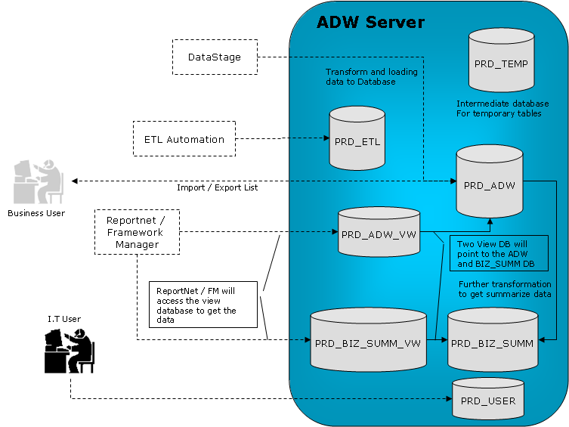

BUSINESS INTELLIGENCE APPLICATIONS
To perform enterprise level of reporting and data analysis, corresponding applications are set up on the BI Server. The analysis result will be presented to users through the intranet web pages. The following is an overall component layout in the BI Server.

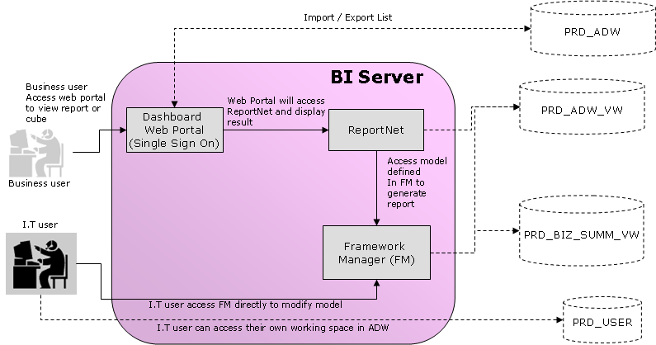

Framework Manager (FM)
Framework Manager provides a common infrastructure across all Cognos business intelligence products. All models used by the ReportNet are defined and stored in the Framework Manager. Framework Manager will act as the bridge of the ReportNet to the ADW Server.

ReportNet / DashBoard Report
ReportNet enables users to view the whole enterprise reports via a web portal. The architecture allows users to create complex queries to explore data from the ADW. ReportNet also provide advanced authoring features such as: integrated text, charts, graphs … etc. The report generated by the ReportNet will be showed by the Dashboard portal to the business users.

Single Sign On
In order to simplify user’s sign-on procedure, single sign on will be configured for the Cognos ReportNet. After the login name is recognized by the Active Directory Server, user can access the Cognos ReportNet portal and require no other authorization.

Import / Export List
After users successfully login the web portal by using the MS Windows Active directory’s authorization, they can perform the import and export list function.

  - HP OpenView
HP OpenView is responsible for the ETL failure and general Teradata problems reporting. In order to allow the HP OpenView capture the failures, we will setup our ETL Automation and AWS to send error messages and Teradata problem to the HP OpenView Server.

DIRECTORY STRUCTURE

APPLICATION DIRECTORY STRUCTURE
For ease of maintenance, most software will be installed in their default location. Below is a list of the installed applications and their installed locations.

ETL Server (bill02)
Software | Directory
Teradata Tools and Utilities | /opt/ttu
ETL Automation | /opt/etl
Netvault Executable  nvtrigger.exe  nvreusemedia.exe | (to be confirm)
DataStage Server | /opt/dsadm
Perl | /usr/bin/perl

BI Server (to be confirm)
Software | Directory
Cognos ReportNet | (to be confirm)
Cognos Content Manager | (to be confirm)

BI Server (to be confirm)
Software | Directory
Cognos ReportNet | (to be confirm)
Cognos Content Manager | (to be confirm)

BI Server (to be confirm)
Software | Directory
Cognos ReportNet | (to be confirm)
Cognos Content Manager | (to be confirm)

Web Server (to be confirm)
Software | Directory
Cognos Gateway | (to be confirm)
IIS | C:\Windows

Web Server (to be confirm)
Software | Directory
Cognos Gateway | (to be confirm)
IIS | C:\Windows

CODES AND SCRIPTS DIRECTORY STRUCTURE
Source files, job scripts will undergo a general directory structure listed as below:

/{ENVIRONMENT}/{FUNCTION}/{APPLICATION}

Variables | Description
ENVIRONMENT | Type of environment (development, testing and production)
FUNCTION | Functional group (ETL, BI)
APPLICATION | Application (DataStage, ETL)

Below is a listing of the designated location to store source files and job scripts:
Production environment on DataStage Server

Development environment on DataStage Server

Testing environment on DataStage Server

USER ACCOUNTS AUTHENTICATIONS AND SECURITIES

BI SERVER USER ACCOUNTS SETTINGS
Below is a list of the user accounts setting on the BI Server:

Server Name | User Name | Cognos Role | User Groups | Description

Cognos ROLE settings
In order to allow domain user to perform different functions for the Cognos ReportNet, different roles will be sat up in the Cognos ReportNet. Bellow is the list of roles and the corresponding privileges:

Role Name | Privileges

TERADATA DATABASE USER ACCOUNTS SETTINGS

Development user accounts authentications and securities
In Teradata, development user accounts are created for the following teams:
- NCR team
- SmarTone – Vodafone IT User
- SmarTone – Vodafone Business User

As for development efficient, development user accounts will have the privilege to access the development databases in the ADW Server. The concept of Roles and Profiles in Teradata RDBMS is practiced for ease of access control of user groups on Teradata database objects.

Production user accounts authentications and securities
In Teradata, production user accounts are created for the following teams:
- SmarTone – Vodafone IT User
- SmarTone – Vodafone Business User

As for securities issue, production user accounts will only have the privilege to access the information they are authorized to study. These user accounts have access only to a subset of the database objects only in the production environment. The concept of Roles and Profiles in Teradata RDBMS is currently in use as group access control for business users.

System Account, Batch account Authentications and Securities
System accounts are used to execute and automated batch process on Teradata RDBMS. You can refer to the SMC – V ADW Project – Naming Standard document for information concerning the format about system and batch account. You can find the detail list of account in appendix 8.3.

Appendix:

DEVELOPMENT, TESTING and PRODUCTION ENVIRONMENT
In order to smooth the development process, different environment will be created for different purpose. For example: We may have development environment for developer to develop and test their script or we may have testing environment to do the SIT or UAT test…etc. These environments will share the same architecture we mentioned in these architecture design document. The differences between these environments are the names we used to represent the environments, for example: PRD_ETL stand for production ETL, DEV_ETL stand for development ETL…etc.

Below is the physical architecture for the development environment.
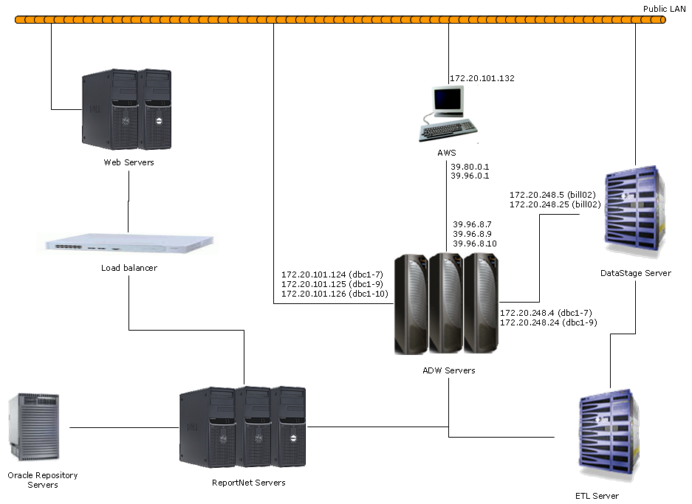

Host File Settings
In order to allow Teradata CLI tools to connect the ADW Server, we need to configure the host file to include the IP address for the ADW Server. Below is the list of the computers which need to be configured:

Computer name
bill02
dbc1-7
dbc1-9
dbc1-10

Teradata USER Account List
System | Account Name | Description | Granted Roles | Owned by | Environment

TERADATA ROLE LIST
System | Role Name | Description | Owned by | Granted Rights

